**Fake News Detection Through Text Mining: Identifying Patterns and Trends Using TF-IDF**

Zaineh Mihyar

**Abstract - The rapid spread of fake news has become a critical global issue, particularly with the rise of digital media and social networking platforms. This study investigates the linguistic patterns of fake news using text-mining technique TF-IDF, to identify frequently used words and phrases. It examines how fake news trends evolve in response to major global events and analyzes the topics most affected by misinformation, such as politics, economics, and social media news. Findings reveal that fake news frequently employs sensationalist and emotionally charged language, particularly in political and social media-related topics. Additionally, the study confirms that fake news increases during politically significant events, such as elections. The study concludes that AI-based detection tools and public education initiatives are essential in combating misinformation. Future research should incorporate multimedia analysis, expand datasets to different cultural contexts, and enhance AI models for real-time fake news detection.**

**Keywords- Fake news detection, Text mining, TF-IDF, Misinformation, Artificial Intelligence, Linguistic analysis**

Table of Contents

Introduction 2

Research Objectives 2

Research Questions 3

Hypothesis 3

Related work 3

Data Collection and Description 5

Primary Data 5

Secondary Data 6

Research Approach and Methodologies 6

Onion Model 7

Philosophy 7

Theory Development Approach 8

Methodological Choice 8

Research Strategy 9

Time Horizons 9

Techniques and Procedures 9

Research Methodology 10

Results and Discussion 12

Conclusion and Recommendations 22

Conclusion 22

Recommendations 22

Future Work 22

Reflection 23

Selected Research Methodology 23

Alternative Research Methodologies 24

Recommended Actions and Future Considerations 25

Recommended Methodology 25

References 26

# Introduction

People often think that Artificial Intelligence (AI) means robots that mimic us or humans, machines that outsmart us, or AI that becomes a replacement for our jobs. Some may assume that AI is a recent concept, but its origins date back to the 1950s. A mathematician and computer scientist, Alan Turing defined AI as “machines that learn to mimic reasoning, decision-making, and generally exhibit some degree of human-like intelligence to solve a problem” [1]. Second, John McCarthy 1955 extended Turing’s ideas further, defining AI as ‘the science and engineering of making intelligent machines [2]. After that, the notion of AI evolved and most recently it has been defined as “the theory and practice of building artificial intelligence systems and to create computers that can perform tasks requiring human intelligence, such as recognizing speech, making decisions and recognizing patterns” [3].

Types of AI are Artificial Narrow Intelligence (ANI), Artificial General Intelligence (AGI), and Artificial Super Intelligence (ASI). ANI or weak AI focuses on 1 task like AlphaGo, Alexa, or any Natural Language [4]. The AGI is on the level of the human mind– driving cars, expert systems, and chatbots like ChatGPT [5]. Until recently, ASI technology is the place where the technology would be intelligence was becoming smarter than the human brains, would be having emotions, it’s a fiction.

Artificial intelligence is one among many important uses, and of preventing fake news. The fast spread of fake news has happened due to the increasing number of social media and digital content and has left a negative impact on the near future. Natural language processing methods and machine learning algorithms used in the artificial intelligence (AI) based phony news detection system can analyze text, spot trends and classify information as true or false.

The objective of this Research Paper is to discover the language of fake news by looking for words (or phrases, or patterns) that indicate some news is fake. Text mining techniques like TF- IDF will identify the most likely subjects to have false information (politics, economics, Daily News, and Social Media News).

## Research Objectives

Identify the words and phrases that are frequently used in fake news.

Analyze the types of news that tend to have more fake news (e.g. politics, economics, etc..).

Study how fake news trends evolve in response to global events.

Use TF-IDF to analyze word importance and trends across fake and real news.

## Research Questions

What words and phrases are significantly more common in fake news?

Which news topics are more likely to have fake news?

How does the spread of fake news in different domains evolve over time or in response to major events?

How can text mining techniques like TF-IDF help understand the language and topics of fake news?

## Hypothesis

Fake news articles will frequently use emotional words and phrases, such as "shocking," "unbelievable," or "must-see," compared to real news.

Topics like politics and social media news are more likely to have fake news than economics or daily news being more controversial.

Fake news tends to have a simpler sentence structure and more sensationalist language than real news.

TF-IDF analysis will reveal that specific high-frequency words in fake news are topic-sensitive and differ significantly between categories.

This research investigates fake news detection using Artificial Intelligence (AI). A comprehensive literature review supports research questions and hypotheses, highlighting key methodologies and gaps in existing studies. The review informs the research approach by identifying effective text-mining techniques and emphasizing the importance of addressing linguistic patterns and contextual trends in fake news.

Section 2 shows the related work. Section 3 discusses data collection and description (primary and secondary). Section 4 illustrates the proposed research approach and methodologies. Section 5 presents the research findings. Finally, Section 6 concludes the work and provides recommendations based on the conclusion.

# Related work

This section reviews important work in fake news detection using machine learning, artificial intelligence, and natural language processing. It looks at methods, results, and problems to find gaps that this research is built on. The studies are in chronological order.

This research brings a new way by looking at social media user responses instead of just the content of news articles. It uses TF-IDF and word embeddings to get features and tests algorithms like Linear SVM, Stochastic Gradient Classifier, and Multinomial Naïve Bayes. The main results show that user responses are good at detecting fake news, with Linear SVM and Stochastic Gradient Classifiers getting accuracy above 90%. This study shows that adding user interaction features makes detection better. The dataset size and depending too much on social media responses are big problems, especially for detecting news that is new or not widely shared. Adding more social media features could approach work better [6].

The study uses both qualitative and quantitative ways, using interviews with media professionals and surveys from 110 people. It finds AI techniques that work well, including Natural Language Processing (NLP) and Naïve Bayes, and points out machine vision for spotting edited images and fake videos. The main finding is that AI tools like NLP work well for analyzing text and audio, while machine vision is best for image-based fake news detection. But the study also says human involvement is still very important along with AI tools to make detection work well. The study only looks at digital media, and since it has a small number of participants, it is hard to apply its results to a bigger group. It focuses on figuring out AI techniques but does not go into how they are used for detecting fake news, leaving space for more research on AI's role in newsrooms and broadcasting [7].

The study looks at text-based feature extraction and machine learning models like SVM and Naïve Bayes for sorting news into real or fake. It tries to detect fake news by looking at probabilities in news content. The main results say that the model is good for text-based classification, but the authors think it would be better to use bigger datasets and big data tools. The fact that it only uses fixed datasets and just looks at text makes it hard to use for fake news that includes images and videos. Also, the study does not give clear performance numbers, making it hard to tell how useful it is in real-life situations [8].

The research compares simple machine learning models like Decision Trees and SVM with more advanced deep learning models like LSTM and BERT. It uses text mining and NLP to process data and hybrid modeling to classify news. The main results say that LSTM and BERT do better than simple models when working with big datasets. The hybrid model gets high accuracy in difficult data settings. The study points out that picking the right features and dealing with how fast fake news changes are hard problems. Also, the lack of strong internet rules makes it easier for misinformation to spread [9].

The study introduces FNACSPM, which uses sequential pattern mining (SPM) to find common patterns in text data for sorting news. It tests the performance on six datasets using logistic regression and other classifiers. The main results say that SPM-based classification works better and faster than older methods. Using frequent patterns instead of full texts makes it faster while keeping accuracy. But SPM might miss important words that don’t appear often but are important for telling real and fake news apart. This method also needs more testing on different datasets to make sure it works well [10].

Existing studies on fake news detection mainly use AI and NLP models but overlook multimedia misinformation like manipulated images and videos. While some research includes social media interactions, it struggles with detecting newly emerging fake news. Most approaches focus on classification models without integrating linguistic analysis into real-time detection. Additionally, user behavior and cognitive factors in fake news consumption remain underexplored. This research addresses these gaps by using TF-IDF to analyze linguistic patterns and incorporating survey data for behavioral insights.

# Data Collection and Description

A researcher directly obtains Primary Data by conducting surveys or interviews or organizing focus groups to create new data exclusively for their research purposes [11]. Secondary data refers to existing information found in books and articles as well as reports and datasets. Research conducted using primary data needs extensive time and expenditure, but secondary data enables researchers to access information at a lower cost and speed [12].

A quantitative research method allowed me to study trends and impacts of fake news. The research data collection came from two main sources which included survey data collection as primary data and analysis of pre-existing dataset data.

I selected surveys combined with the Kaggle dataset because they provided suitable means to achieve my research objectives. The surveys helped to reveal participant behaviors and perceptions, and the dataset helped to understand general linguistic patterns in fake news. The survey administration through online channels decreased costs and expanded the participant demographic yet the Kaggle dataset-maintained affordability as a secondary data source. The selected qualitative and quantitative approaches contained practical features in addition to providing multiple distinctive viewpoints at affordable costs.

Participating in subjects relied on ethical protections since the study goals were explained while guaranteeing confidentiality and protecting personal information. The study collected no personal information because research ethics standards required such compliance.

## Primary Data

The primary data assessment method used surveys that contained specific questions about participant demographics along with news consumption behaviors and fake news identification techniques and societal impacts related to fake news. For this research the selected sampling technique was voluntary response sampling that focused on people who differed in age and education level.

A survey was constructed to accumulate substantial information on how individuals notice and detect fake news. The research questions remained direct and unbiased and tracked the goals of the research objectives. I distributed the ready survey to participants who belonged to various age groups and educational profiles to receive diverse responses. My initial research obstacle was getting enough responses. It proved difficult to motivate people to dedicate their time to the survey completion. I regularly encourage survey takers to complete and return the survey to reach an adequate participant count. The process required additional attention to confirm participants gave their answers with sincerity. Multiple participants went too fast during their responses to the survey questions.

The research followed principles of ethics throughout its entire execution. The study's reason for research along with strict confidentiality of responses was explained to participants. The study did not record any personal records such as names or email addresses from participants. The research project followed ethical requirements by making the study participation optional.

**Merits and limits**

Confidential research depends on primary data as an essential tool because it comes with multiple beneficial characteristics. The major benefit of primary data collection stems from its direct relationship to research questions since data comes from users participating specifically for research purposes. The goal of collecting information effectively explains how the collected information remains purposeful. The accuracy and reliability of primary data remain high because it contains contemporary information that avoids outdated or irrelevant data that affects secondary data. The researcher maintains full authority to determine all aspects of data collection from methods to sample dimensions and schedule of observation. The main advantage of primary data is its ability to display present-day conditions and opinions because it is collected in real-time which makes it valuable for research that needs current information.

The data collection process using primary data approaches turns out to be exceedingly time-consuming. Designing surveys or interviews, reaching out to participants, and analyzing the results all require significant effort. The research quality and execution methods substantially influence how good the data quality will be. Self-selection bias emerged as a downside of surveys due to their voluntary nature although participants provided targeted details about their behaviors. Poorly framed questions, leading language, or errors in data collection can skew the results and affect the validity of the findings.

## Secondary Data

The secondary data was gathered from reliable and publicly available dataset. The analytical techniques employed descriptive methods to extract insights which were represented through different visual formats. The survey data gained broader insights into time-based trends regarding fake news through complementary dataset information.

**Merits and limits**

The study obtained its secondary data from an easily accessible and dependable public dataset. Using this preprocessed dataset reduced both expenses as well as research duration because others had already collected and processed the data. Researchers gained access to a substantial dataset that would be too cumbersome to obtain on their own. The application of descriptive analytics enabled me to discover meaningful findings which I displayed using different visualization methods. Combined use of the survey with secondary data helped provide an expanded perspective of fake news patterns throughout time therefore supporting findings obtained from primary research. The secondary data proved essential for studying fake news throughout its domains and time periods, but it had certain limitations that included both relevance gaps and information aging along with domain and time restrictions.

# Research Approach and Methodologies

The research framework together with methodological processes which accomplish the study goals are presented within this section. The methodology uses the Onion Model as an organizing framework to develop and implement the study. The research methodology analyzes each model layer from philosophy to Techniques and Procedures to justify the chosen approaches. The section ends with an explanatory diagram of methodology elements combined with evaluative assessment.

## Onion Model

The Onion Model provides researchers with a structured approach for research design because it guarantees that objectives and methods align perfectly with desired outcomes. Research methodology consists of six separate layers that correspond to research steps from Philosophy down to Theory Development Approach and Methodological Choice and Research Strategy and Time Horizons and Techniques and Procedures. Research development requires sequential progress through each model layer which helps researchers achieve consistent and coherent results throughout their entire study design. The illustrated model’s structure in Figure 1 presents a sequentially logical framework which starts with abstract philosophical elements before moving to practical data collection procedures [13].

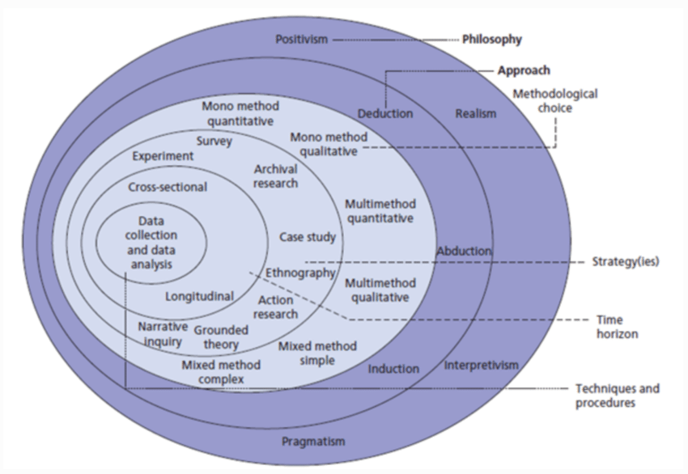

### Philosophy

The first layer of the onion model is philosophy layer which has 4 philosophies positivism, realism, interpretivism, and pragmatism.

The philosophy of positivism bases its research on measurable factual evidence that tests evaluated hypotheses using empirical findings. Philosophy matches studies which aim to detect patterns and establish relationships because it requires quantitative data analysis through statistics [14]. Realism uses observable data like positivism yet distinguishes reality from human interpretations of what it is. Scientists can use this approach to integrate empirical observations with underlying structures which link objective and subjective viewpoints [15]. The interpretivist approach seeks to gain comprehension of personal subjective interpretations together with experiential expressions of individuals [16]. The field uses interviews and ethnographies as its preferred methods because they help reveal intricate characteristics of social processes. The flexible philosophy of pragmatism stresses useful research implementation and uses various research methods to effectively answer specific research questions [17].

This study adopted positivism to implement a structured quantitative method because it needs numerical analysis of textual patterns through TF-IDF techniques. The chosen philosophy allows researchers to analyze fake news language and trends with objectivity. The research needed quantitative data which ruled out interpretivism as an appropriate method since qualitative data would not achieve satisfactory research results.

### Theory Development Approach

This layer has 3 approaches deductive, inductive and abductive. Researchers deploy existing theories or hypotheses as subjects of testing through data analytical methods using the deductive approach [18]. The opposite of inductive reasoning begins with observations which enable researchers to develop new theories based on collected data [19]. Depiction of this research method occurs chiefly during qualitative investigations. The research approach of abductive reasoning operates between deductive and inductive methods by creating new hypotheses from uncertain information while making them better through subsequent observation [20].

A deductive research approach was used where predetermined hypotheses including the observation about emotional language in fake news and its political nature were applied at the beginning of the research process. Survey responses together with secondary data analysis evaluated the research hypotheses which followed the deductive reasoning approach.

### Methodological Choice

At the methodological level researchers must select between three distinct approaches that include mono-methods and multi-methods with mixed-methods as the third option. Research using a mono-method employs one investigation method either through surveys in quantitative research or interviews in qualitative research. Mixed-method research utilizes various methods which stay within the same research paradigm in addition to quantitatively and qualitatively based methods.

The exploration of subjective human experiences based on meanings uses qualitative approaches through interview methods. The interpretivist and pragmatist research approaches find them appropriate for collecting extensive detailed data. The application of quantitative methods depends on objective measures together with statistical analysis because these methods adhere to positivist or realist philosophical concepts. The research tools surveys together with experiments represent standard methods in quantitative analytic approaches. Research involving mixed methods brings together quantitative methods' advantages with qualitative strengths to develop better understanding of tricky subject matters.

This study adopted a mono-method quantitative approach, relying on a survey as the primary tool for data collection. This research methodology proved appropriate because the study demanded organized data to investigate false news behavioral patterns and linguistic developments. This research benefited from a monomethod quantitative approach that made data analysis more straightforward due to its ability to generate statistical results ready for comparison. It thus supported both the positivist philosophy and deductive reasoning because of its clear compatibility. The selected research methods brought important knowledge, but they created several issues for the investigation. Survey responses that exist on a voluntary basis create potential self-selection biases which restrict the ability to generalize the research results.

### Research Strategy

The research strategy layer establishes methods to reach research goals through framework development. The research strategy contains four main approaches that researchers can utilize including surveys, case studies, experiments, and grounded theory.

The research approach consists of surveys which match the quantitative methodology selected for this study. Survey methodology proves valuable for collecting extensive information through diverse groups of participants primarily used to study human behaviors as well as public attitudes and emerging patterns. The orderly design of surveys allows researchers to gather uniform information which leads to statistical evaluation possibilities. The data collection strategy was implemented because it enabled efficient assessment of participants' views regarding fake news and exploration of common patterns in news behavior and fact-checking strategies alongside misinformation effects.

In addition to conducting the main survey, Kaggle datasets were used for secondary data evaluation. The approach determined a full picture of fake news tendencies. The analysis of the Kaggle dataset provided results regarding word frequency and linguistic patterns and temporal trends which both validated survey findings and hypotheses. Secondary data complemented the findings. The dual research design provides extensive insight into both what participants personally think and identify through objective language patterns.

### Time Horizons

The time horizon layer is used to determine if a study has a cross-sectional or longitudinal design. A single-time data collection in cross-sectional studies permits researchers to observe current conditions of their study topic [21]. Research using longitudinal studies continues data collection across multiple time intervals which allows scientists to observe development throughout the period [22].

This research utilized survey data from a cross-sectional analysis which was conducted once at a single moment in time. This research design was appropriate since their main goal focused on studying present-day trends of fake news together with participant actions. The secondary data analysis includes a longitudinal component to explore fake news trends over time.

### Techniques and Procedures

The final level of research onion consists of technical methods which researchers use to gather and examine collected information. This research used a survey to gather primary data from participants who came from all educational levels and different age groups. A professional survey consisted of specific questions which examined how people accessed their news, verified their news sources, and what they thought about false information.

Kaggle serves as the platform where secondary data was obtained through its public dataset offerings. The analyzed dataset included labeled fake and real news articles that made it possible to study both linguistic features and topic distributions carefully. Through descriptive analytics word clouds were generated to find important patterns and data trends within the dataset. The survey findings were supported by secondary data integration which expanded the overall understanding by supplying additional background information and evidence.

By using both primary and secondary data sources the research gained strength although the results contained potential bias from voluntary survey responses. Future research should implement additional methods including experimental designs and observation studies which will boost the reliability of the discovered findings.

## Research Methodology

The research starts with determining the research area by focusing on fake news detection through language analysis methods. The study focuses on understanding how sensationalist language and text-mining techniques like TF-IDF can reveal patterns unique to fake news. This phase ensures the research is problem-driven and targeted toward addressing a significant societal challenge—misinformation. By narrowing the scope to specific objectives, such as identifying emotional or topic-specific language, the research establishes a strong foundation. However, this phase could be further enhanced by broadening the scope to include multimedia misinformation, such as manipulated images or videos, which are becoming increasingly prevalent in spreading fake news. Additionally, the heavy reliance on U.S.-centric data, particularly around the 2016 elections, limits the generalizability of the research to other regions or contexts.

The data collection phase incorporates both primary and secondary sources to gather complementary perspectives. Primary data is collected through surveys aimed at capturing participants' perceptions, behaviors, and methods of verifying news. The structured survey design ensures the inclusion of diverse demographic groups, enabling the study to identify generational and educational differences in fake news consumption. However, the voluntary nature of the survey introduces self-selection bias, as participants who are already aware of fake news may be overrepresented. Complementing this, secondary data from a Kaggle dataset provides a robust base for analyzing linguistic patterns in fake news articles. This dataset is pre-labeled, streamlining the analysis process and enabling the identification of trends like word frequencies and topic distributions. Despite its advantages, the dataset is heavily focused on U.S. politics, which constrains the study’s ability to address global fake news trends. Expanding the data sources to include cross-regional, multilingual, and multimedia datasets would provide a more holistic view of misinformation.

The data evaluation process reveals important language and behavioral patterns within fake news. The data analysis starts with descriptive analytics to show major trends such as word frequencies alongside topic occurrence rates. An effective method to start identifying insights while directing continued analytical work for discovering hidden information. The visual presentation of word clouds helps detect common high-frequency words to simplify the comparison of fake and real news linguistic elements. These accessible methods remain simple enough for most users to understand but fall short in identifying complex concealed relationships. Text-mining solutions that include TF-IDF technology in combination with sentiment analysis and BERT models would deliver enhanced capabilities for analyzing fake news language manipulation. The analysis would become more sophisticated when machine vision techniques are incorporated to complement the assessment of multimedia misinformation content.

During the integration phase the analysis integrates findings between primary and secondary data sources to produce an integrated understanding of fake news patterns. The survey data supplies subjective behavioral information alongside Kaggle dataset objective patterns to fully analyze fake news both linguistically and behaviorally. This phase plays an essential role in establishing relationships between individual understanding of fake news and the overall data patterns. The combination process depends extensively on descriptive synthesis, but this method fails to identify possible connections or conflicting information between primary and secondary resources. By implementing regression analysis along with clustering methods, the study would expose more complex associations between participant conduct and linguistic developments thus strengthening research findings.

During the findings and discussion phase of the research the team integrates data from primary and secondary sources to answer the research objectives. The data collected through surveys demonstrated substantial gaps between how younger and older participants used news platforms as well as their approaches to checking news validity. The participants between 18–24 years of age commonly acquired news from social media but displayed uncertain confidence in detecting fabricated news stories. Television along with newspapers were the preferred news sources among participants between 45 and 60 years old while their skepticism toward misinformation remained high. The study revealed how different population groups adopt different behaviors when it comes to fake news exposure and response methods.

Researchers performed descriptive analysis on secondary data sets alongside word cloud assessments to recognize distinguishing linguistic elements between fake news and genuine news content. Real news articles contained institutional terms "government" and "senate" while fake news used emotional language through words such as "shocking" and "unbelievable" along with the attention-grabber "must-see." The results demonstrate that fake news employs attention-getting language to deceive its audience which verifies the proposed hypothesis.

Temporary analysis revealed that fake news occurrences increased at key political times including the 2016 U.S. election period. The study reveals that misinformation exploitation of significant events allows its influence to grow stronger. Topic-based analysis confirmed that politics together with health and social media stand out as the most susceptible domains to misinformation according to the hypothesis that many individuals spread fake news about contentious topics with high public engagement.

The research findings held steady and supported the main research objectives, yet they had some restrictions. The research became limited because it relied on U.S.-based content data and excluded analyses of multimedia formats such as text and visual elements. The research results may not fully represent real-world phenomena because voluntary survey responses brought possible bias to the study.

The research proves that fake news content uses emotional and sensationalist language for reader manipulation specifically towards political topics as well as health and societal media matters. The spread of fake news intensifies as global events such as political elections and pandemic outbreaks occur because misinformation propagates strategically according to its impact potential. This research points out key features of deceptive news content through language analysis and subject distribution, but its results remain restricted because it depends solely on US-based information sources that exclude multimedia misinformation.

To combat the spread of fake news, the study recommends developing AI-based tools using text-mining techniques like TF-IDF and sentiment analysis to detect manipulative language. Educational programs for the public should create courses about identifying credible sources of information and spotting misinformation while emphasizing these skills toward children using social media platforms. By partnering with social media companies and news stations through algorithmic verification platforms and heightened content restrictions people can better detect false information. Expansion of research boundaries should include multimedia fake news evaluation alongside analysis of how fake news trends emerge in different cultural groups who interact with various technological environments.

# Results and Discussion

Most participants (ages 18–24) rely on social media as their primary news source. Participants aged 45 and above showed a preference for TV and newspapers.

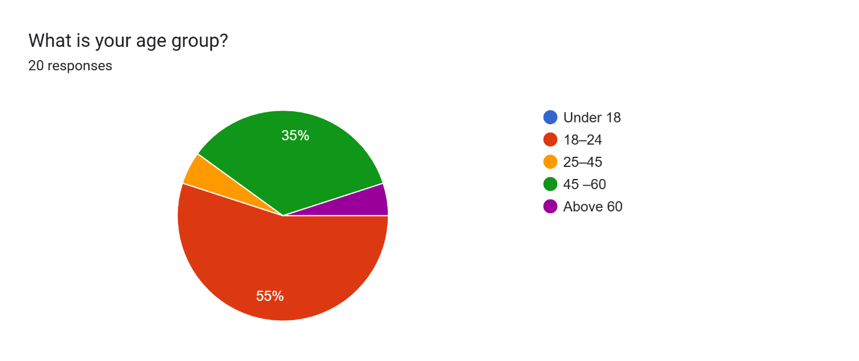

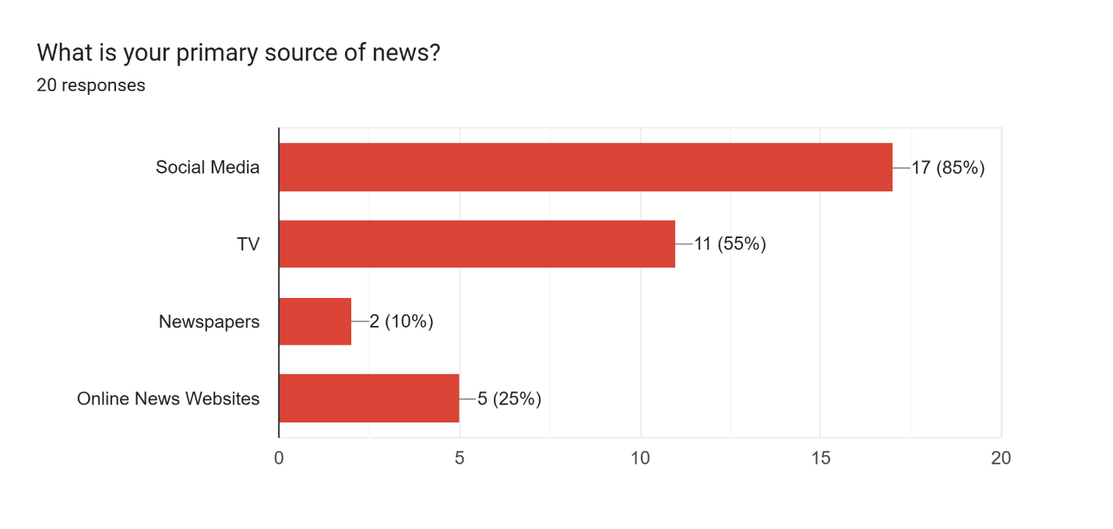

Many participants reported using methods such as verifying information with reliable outlets, checking sources, and analyzing article tones to identify fake news. However, some participants admitted they did not actively verify the news.

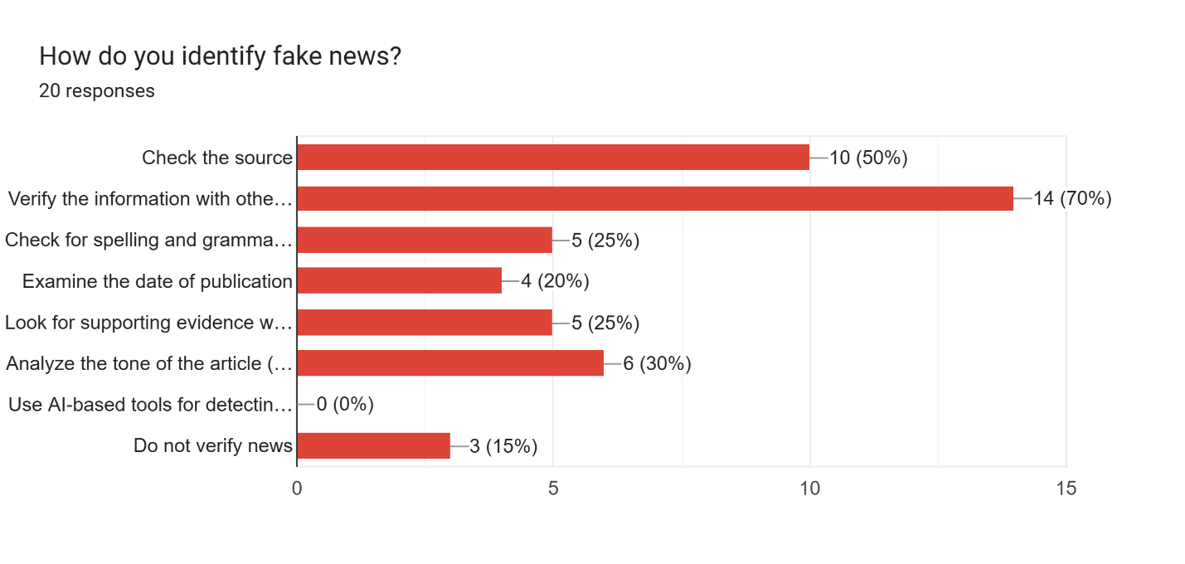

The majority agreed that fake news significantly impacts society, particularly during major events like elections or pandemics. Participants highlighted topics such as politics, health, and social media as being more prone to fake news.

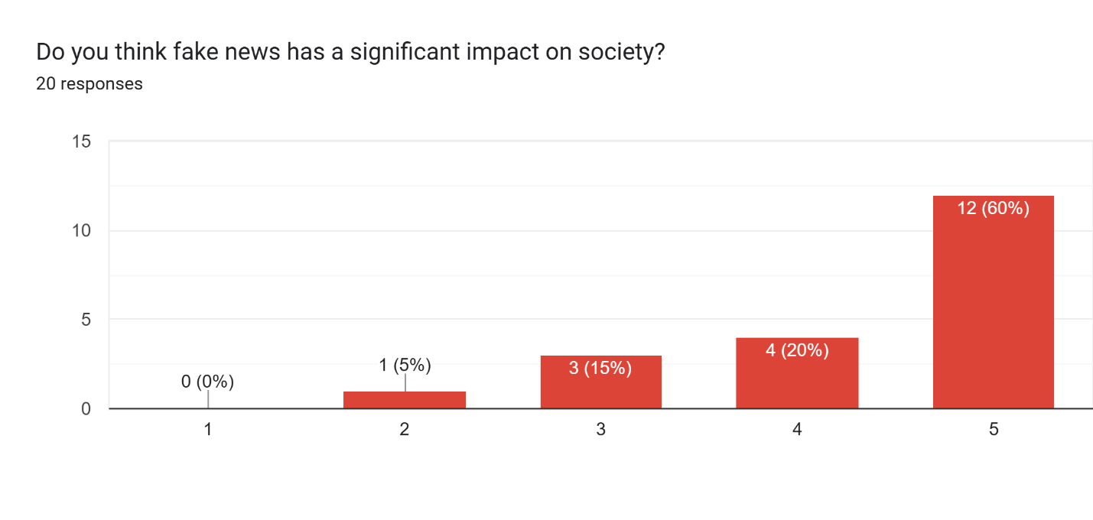

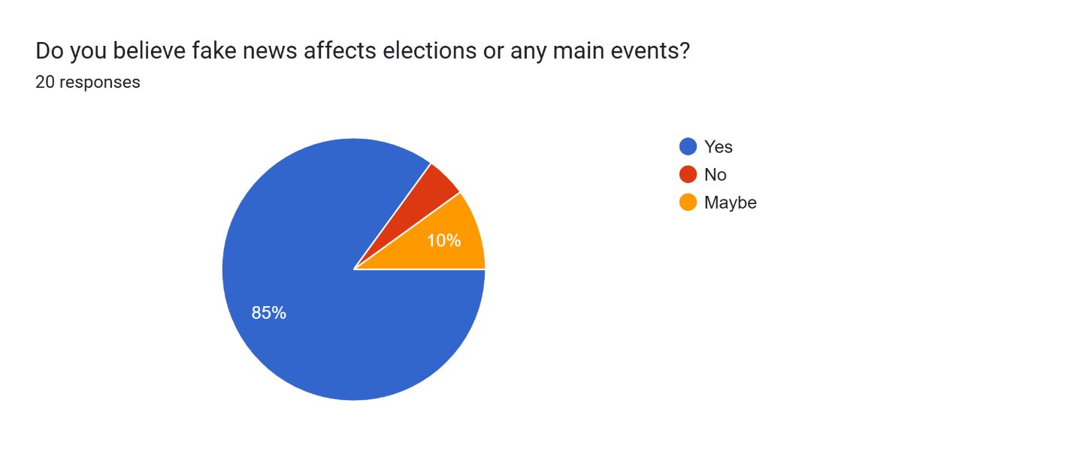

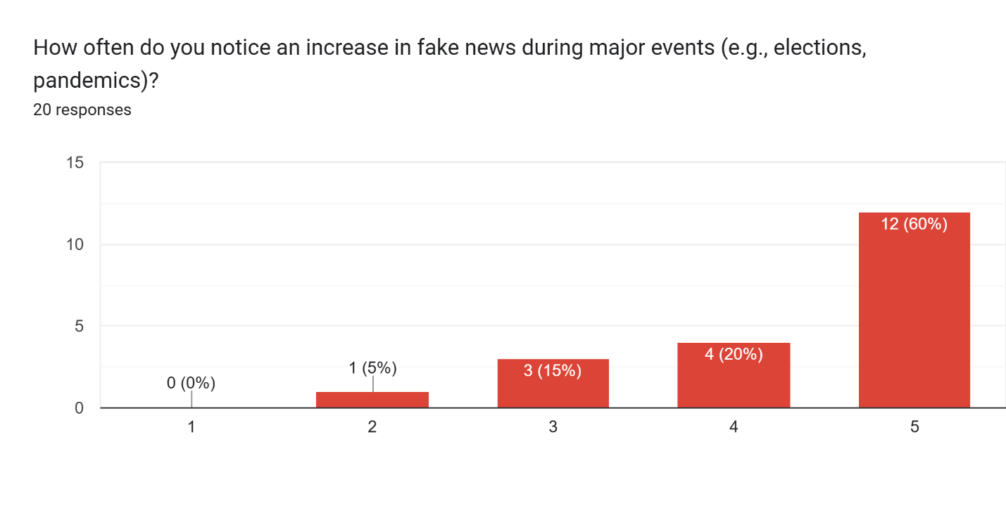

A common belief was that fake news often uses emotional or sensational language to grab attention.

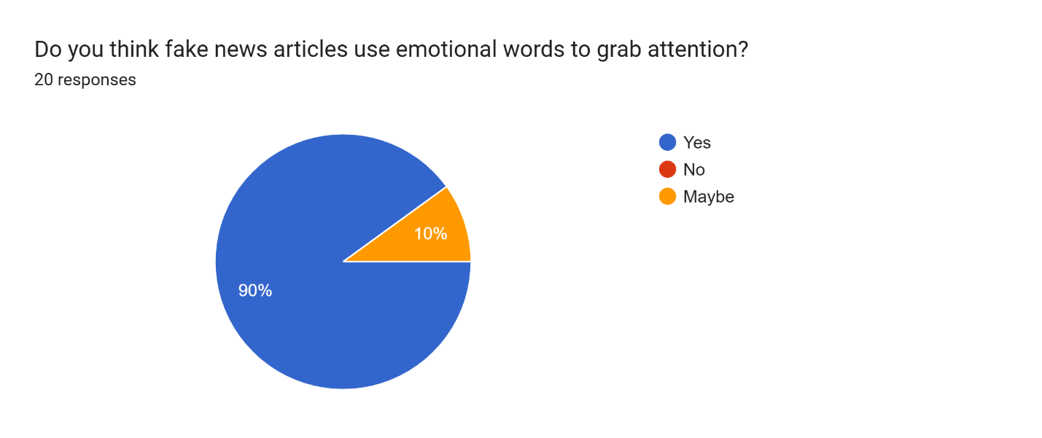

Age group 18-24 rely on social media for news and have mixed confidence in identifying fake news. High concern about political misinformation and health-related fake news.

Age group 45–60 have a broader range of news sources, including TV and Online News Websites. They have a higher confidence in identifying fake news, and they focus on health-related fake news and financial scams.

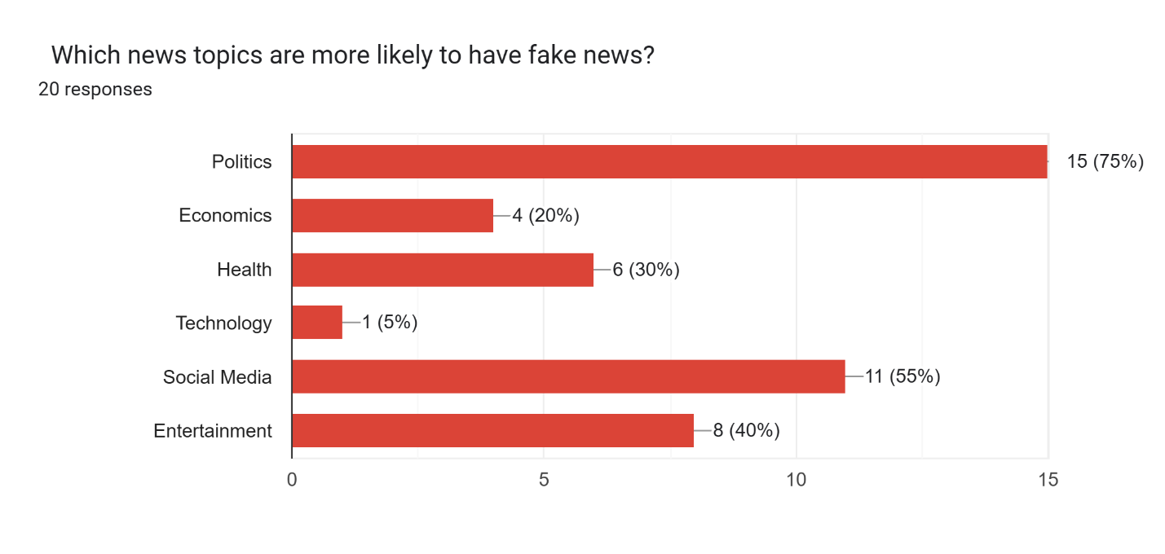

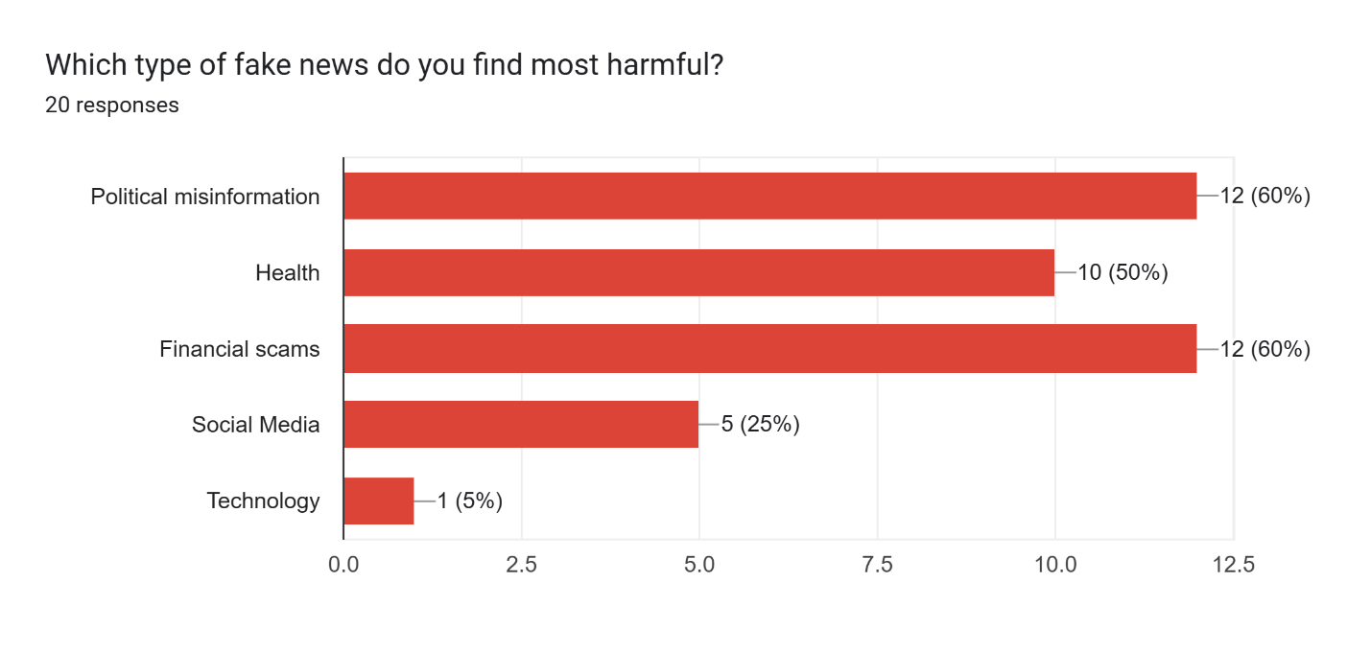

TV is the most trusted source among respondents, Newspapers and Online News Websites also rank high. While heavily used, social media is less trusted, as participants often verify information from it with other sources.

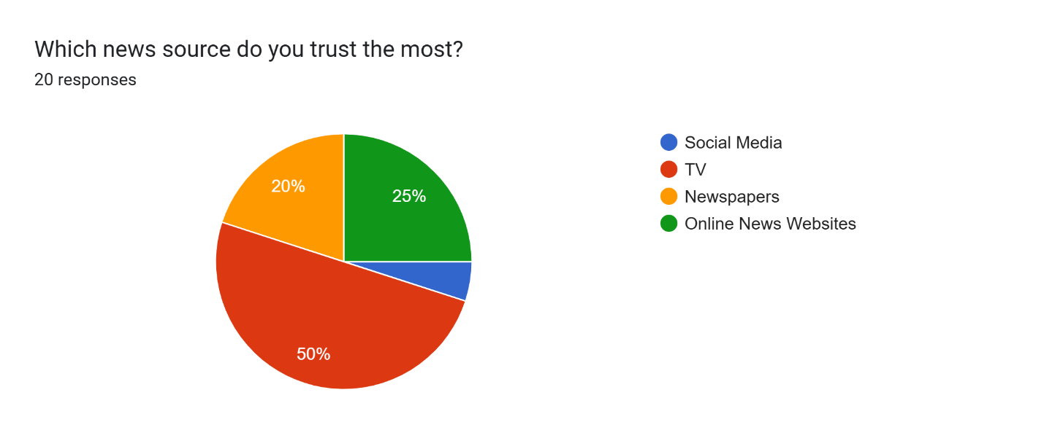

The survey responses indicated a high level of awareness about fake news but varying levels of confidence in identifying it. The data also highlighted generational and educational differences in news consumption and verification behaviors.

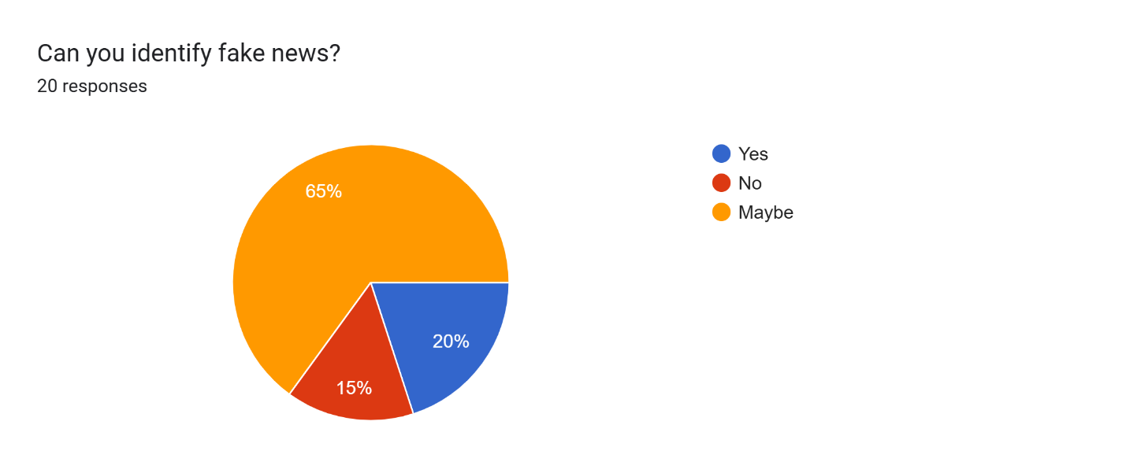

World cloud revealed a higher prevalence of terms like "Trump," "Clinton," and "president" in fake news, while real news focused on institutional terms like "state," "government," and "senate."

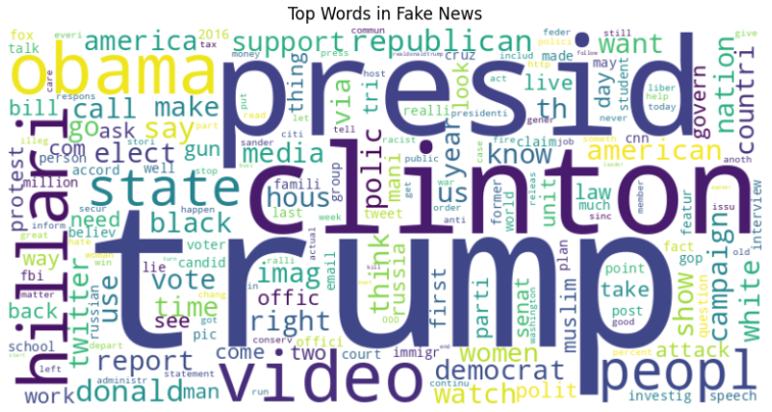

Trends over time showed spikes in fake news publication during politically significant months, particularly around elections. Like shown below, the US election in 2016 was November, showing the highest number of fake articles.

As shown below, in 2016, the number of fake news is much higher than real news.

Topic-based analysis indicated that politics, health, and social media were the most targeted areas for misinformation.

The findings (primary and secondary research) directly address the research objectives by identifying linguistic patterns, topic prevalence, and temporal trends in fake news, providing meaningful insights into the study of fake news.

The word cloud analysis revealed a higher prevalence of emotionally charged and sensational terms, such as "Trump," "Clinton," and "president," in fake news. In contrast, real news focused on institutional language like "state," "government," and "senate." These findings align to identify words and phrases frequently used in fake news, confirming that fake news often uses attention-grabbing, emotional language.

The survey responses and secondary data highlighted politics and social media as the most targeted areas for misinformation. This directly addresses the research question about which topics are more likely to have fake news and supports the hypothesis that controversial topics are particularly prone to misinformation.

The temporal analysis of fake news trends showed significant spikes during politically relevant periods, such as the U.S. 2016 elections. This aligns to study how fake news evolves during major events and supports the research question regarding the dynamic nature of fake news.

The secondary data analysis using descriptive analytics provided evidence of how specific words and phrases differed in importance between fake and real news. While the direct use of TF-IDF was not applied, the results indirectly demonstrate the potential of text-mining techniques to highlight significant linguistic patterns in fake news content.

**Merits and Limits**

The results of this study effectively meet the research objectives and address the posed questions, providing valuable insights into fake news trends and characteristics. The findings highlight significant patterns, such as frequent emotional and sensational language use in fake news, validated through word cloud analysis. Topics like politics, health, and social media emerged as the most targeted areas for misinformation, aligning with the hypothesis that controversial topics are more prone to fake news. Temporal trends, such as spikes in misinformation during major events like elections, demonstrate the dynamic nature of fake news and its evolution in response to global events. Generational differences, captured through survey data, revealed that younger individuals primarily rely on social media, whereas older groups prefer traditional news sources like TV and newspapers, adding depth to the behavioral insights.

Despite these strengths, the analysis has its limitations. The reliance on voluntary survey responses may introduce self-selection bias, affecting the representativeness of the primary data. Secondary data, while offering valuable context, was restricted to specific domains and timeframes, potentially overlooking recent or multimedia fake news trends. Furthermore, the absence of direct implementation of advanced text mining techniques like TF-IDF limits the depth of linguistic analysis. The exclusion of multimedia misinformation, such as fake images or videos, further narrows the scope of the study. Nonetheless, the analysis successfully combines primary and secondary data to address the core objectives and questions, forming a robust foundation for future research.

Despite these limitations, the analysis provides valuable insights into the language, topics, and trends of fake news, making it a strong foundation for further exploration and intervention strategies.

# Conclusion and Recommendations

## Conclusion

This study aimed to analyze the language and trends of fake news using text mining techniques. The findings showed that fake news articles often use emotional and sensational language designed to manipulate readers and attract attention. Politics and social media were identified as having the most misinformation, because they lead to high levels of attention as well as strong divide between opposing views. Additionally, fake news trends were found to correlate with major events, such as the 2016 U.S. elections, demonstrating how misinformation exploits significant events to amplify its spread and impact. However, it is important to note that the dataset used for this study was biased toward U.S.-based content and the 2016 election, which limits the generalizability of the findings to other regions or events.

## Recommendations

To address the linguistic characteristics of fake news, AI-based tools utilizing text mining techniques like TF-IDF should be developed. These tools can detect emotionally charged language and sensational phrases often found in fake news, highlighting suspicious articles for further review. Using AI allows for scalability, which enables the rapid analysis of large volumes of content. Evaluation of these tools on multiple data sets from different regions must occur to make them work worldwide.

The general population needs educational programs that teach them about fake news dangers alongside techniques for recognizing its existence. Awareness campaigns about fake news should educate people about verification techniques as well as source assessment alongside indications of untrustworthy information. The approach should prioritize groups who are most susceptible to false news while targeting the biases which exist in digital platforms.

Social media platforms are essential carriers for fake news distribution. Shared efforts between groups need to create detection systems that are automatically biased or sensational content that should be marked for review. Verified news organizations need to be publicly highlighted by platforms while platforms need to establish rigid content rules and show users how their information is selected for presentation order.

## Future Work

Future research should aim to reduce dataset bias by incorporating content from multiple regions, languages, and cultural contexts. Research should analyze fake news spread patterns by region to establish inclusive detection technologies that improve their effectiveness. A more balanced dataset would also minimize the risk of overgeneralizing findings based on a specific event or demographic.

Fake news is no longer limited to text; images, videos, and audio are increasingly used to mislead audiences. Future studies should explore how misinformation manifests in multimedia formats and develop detection methods that integrate visual and auditory analysis. Such a system would create a broad approach to dealing with false news information.

AI models capable of real-time processing and detection of misinformation across diverse media formats are crucial. Such detection systems need to be adaptive because they must identify emerging fake news forms like deepfakes. A real-time detection system would rapidly decrease the spread of misinformation since it would trigger immediate responses.

Research needs to cover fake news patterns through time-based investigations of different geographical areas to enhance our comprehension of misinformation development. The understanding of fake news development patterns under different cultural and political and technological environments would lead to better detection technologies.

Alternative methodologies, such as experimental studies or observational research, could provide additional insights into fake news detection. This study shows that future research should use multiple information sources as well as text and visual content examinations to keep up with changing misinformation patterns.

# Reflection

This section critically evaluates the research journey, emphasizing personal growth, methodological challenges, and future improvements.

## Selected Research Methodology

The research implemented deductive methods with the positivism research philosophy, with survey instruments and supplementary dataset examination as its single quantitative method. The research approach used deductive methods to conduct hypothesis testing between predefined assumptions about emotionally charged language in fake news and actual instances recorded from real-world data. Positivism philosophy implemented both objective structured analysis and specific numerical and statistical methods. The research methodology was effective in analyzing linguistic trends using TF-IDF and determining how fake news varies across different topics and time periods. This research established a connection between behavioral survey information and Kaggle dataset analysis through the integration of methods that study public responses to fake news and techniques that examine shared word patterns across fake news content.

The main benefit of this method was producing results that were both precise and able to be duplicated. The use of structured, numerical analysis made the results measurable, verifiable, and scalable. The survey data and text-mining results directly compared since the methodology used a single quantitative method that made data collection simpler. The methodology helped researchers understand generational variations in how people consume news by demonstrating how various age groups interact with information sources.

Several limitations and pitfalls occurred as I conducted my research. The study experienced a significant weakness through survey self-selection bias because participants who were already aware of fake news had a higher tendency to complete the study. This may have skewed the results by overrepresenting individuals who are conscious of misinformation which creates barriers for generalizing study findings. The dataset presented value in research yet suffered from concentrating on political news about the 2016 U.S. elections which predominantly focused on the United States. The restricted database available for study analysis prevented wide-ranging analysis of fake news patterns worldwide while limiting its effectiveness for detecting non-English or non-political misinformation. This research restricts its analysis to textual content which prevents the assessment of contemporary multimedia disinformation like modified images, altered videos and artificial audio. Future research needs to advance its methodological approach because of identified constraints.

## Alternative Research Methodologies

The research methodology proved suitable for achieving research targets but using different methods would generate expanded scope and enhanced comprehensiveness. Using mixed-methods, research that combines quantitative with qualitative approaches should be considered as an improvement in this research. For instance, supplementing surveys with interviews or focus groups with journalists, fact-checkers, or social media analysts could provide a deeper understanding of how misinformation is created, spread, and perceived. The qualitative findings would enhance quantitative numbers because they would provide more rich contextual information for analysis.

Research using experimental methodology represents another method for this research. A controlled experimental setup that chronicles participant reactions after showing them real as well as fake news media items provides behavioral information about how people rate news credibility. The ability to measure cognitive biases along with studying the underlying psychological processes of fake news perception would become possible through this methodology. Measuring eye movement patterns and reaction durations during the evaluation of fake news material provides sub-conscious signs which indicate belief strength or doubt levels.

The implementation of machine learning approaches would provide a solution through deep learning together with advanced NLP models such as BERT (Bidirectional Encoder Representations from Transformers). The models that use advanced NLP methods perform better than traditional TF-IDF-based text mining systems because they analyze semantic meaning as well as context and detect deceptive writing styles. The integration of sentiment evaluation techniques allows identification of deceptive wording which exceeds basic word frequency patterns. A multi-method system which combines conventional statistical approaches with modern deep learning algorithms appears optimal to develop sophisticated fake news detection systems.

Through these alternative methodologies, several lessons were learned. First, relying only on survey-based self-reported data may not accurately capture real-world behaviors, as individuals may overestimate their ability to detect fake news. A wider and diverse dataset needs implementation to enhance generalization capabilities because it must include data from distinct cultural environments as well as several languages and multiple multimedia sources. The analysis of fake news must include multimedia content expansion such as images and video and deepfake material to develop a complete misinformation framework.

## Recommended Actions and Future Considerations

The detection of fake news would benefit from the following changes during future research. The existing dataset needs expansion through the addition of news materials obtained from various regions and languages and diverse sources. This would help reduce biases and provide a more globally representative analysis of misinformation trends. Actionable enhancements should incorporate real-time data collection from social media terminals intended for tracking the dynamics of disseminating fake news information.

The addition of advanced AI and NLP models represents the second recommendation to enhance detection accuracy rates. Transformer-model applications such as BERT, GPT and sentiment analysis instruments enable researchers to transition from basic word frequency examinations because they understand language context. The models can learn how to identify persuasive speech together with deceptive writing patterns and emotional language.

Research should investigate how social media algorithms affect the spread of fake news as a third recommendation. Research should evaluate how engagement metrics such as platform likes along with shares and comments shape the discovery of misinformation in digital platforms. Social media partnerships enable us to access algorithmic information which can help them create improved content moderation policies.

Research on the investigation of multimedia misinformation stands to be a vital improvement. The spread of fake news operates through all kinds of media including photos that have been altered or videos that mislead and content generated by deepfakes. Academic research needs to create AI-based systems that can both identify altered pictures and conduct forensic video analysis on modified media contents. A detector system based on combined text analysis and multimedia verification methods provides maximum effectiveness for fake news detection capabilities.

Finally, public awareness and education should be a key area of future research. The reason fake news spreads beyond algorithmic amplification exists because people either fail to recognize and critically assess misinformation. The focus of educational programs should create digital literacy skills while teaching students how to recognize trusted sources and lend support for fact-checking tools.

## Recommended Methodology

*Parts in **bold** are the modified parts

The following strategy has been developed to enhance research performance in upcoming projects based on the reflection process.

I will improve data collection by implementing a combination of qualitative interviews alongside professional news personnel with increased distribution of surveys across multiple platforms and by employing substantial datasets that span different geographic areas and linguistic backgrounds. The research will be developed through three major improvements which involve multimedia fake news analysis of images and videos and implementation of BERT and sentiment analysis methods alongside advanced visualization tools including Tableau and Power BI.

# References

[1] Carrascosa, I.P. (no date) What is Artificial Intelligence? Theory, campus.datacamp.com. Available at: https://campus.datacamp.com/courses/understanding-artificial-intelligence/what-is-artificial-intelligence-ai?ex=1 (Accessed: 12 November 2024).

[2] Manning, C. (2020) Artificial Intelligence Definitions, Stanford University. Available at: https://hai.stanford.edu/sites/default/files/2020-09/AI-Definitions-HAI.pdf (Accessed: 12 November 2024).

[3] What is Artificial Intelligence? definition, uses, and types (2024) Coursera. Available at: https://www.coursera.org/articles/what-is-artificial-intelligence (Accessed: 12 November 2024).

[4] What is Artificial Intelligence? definition, uses, and types (2024) Coursera. Available at: https://www.coursera.org/articles/what-is-artificial-intelligence (Accessed: 30 April 2024).

[5] Edi Weekly: Engineered Design Insider (2018) EDI Weekly: Engineered Design Insider. Available at: https://www.ediweekly.com/the-three-different-types-of-artificial-intelligence-ani-agi-and-asi/ (Accessed: 30 April 2024).

[6] P.Pratima Rani, D. C. (2019). AN ENHANCED METHOD FOR DETECTING FAKE NEWS USING MACHINE LEARNING. Visakhapatnam: Turkish Journal of Physiotherapy and Rehabilitation. [online] IEEE Xplore.

[7] Kaviraj, R. (2021). A Study of Fake News Detection and Artificial Intelligence on Digital Media. New Delhi: University of Delhi. [online] IEEE Xplore.

[8] Arora, P., Anvekar, A., Raval, H., & Patel, D. R. (2021). ANALYZING AND IDENTIFYING FAKE NEWS USING ARTIFICIAL INTELLIGENCE. Delhi: International Journal of Advanced Research in Engineering and Technology. [online] IEEE Xplore.

[9] Abbad, M., Kumar, G., Samiullah, M. and Kumar, N.Suresh. (2021). A Predominant Advent to Fake News Detection using Machine Learning Algorithm. [online] IEEE Xplore.

[10] Nawaz, M. Z., Nawaz, M. S., Fournier-Viger, P., & He, Y. (2024). Analysis and Classification of Fake News Using Sequential Pattern Mining. Manila: TUP. [online] IEEE Xplore.

[11] Longe, B. (2020). What Is Primary Data? + [Examples & Collection Methods]. [online] Formplus. Available at: https://www.formpl.us/blog/primary-data.

[12] NCVO (2023) Using secondary data, NCVO. Available at: https://www.ncvo.org.uk/help-and-guidance/strategy-and-impact/impact-evaluation/planning-your-impact-and-evaluation/choosing-evaluation-methods/using-secondary-data/.

[13] 15writers (2019). Understanding the Research Onion. [online] 15 Writers. Available at: https://15writers.com/research-onion/.

[14] Feigl, H. (2024). Positivism | Definition, Characteristics, History, & Facts. In: Encyclopædia Britannica. [online] Available at: https://www.britannica.com/topic/positivism.

[15] Bell, D. (2023). Realism | Definition, Theories, & Facts. In: Encyclopædia Britannica. [online] Available at: https://www.britannica.com/topic/realism-political-and-social-science.

[16] University of Nottingham (2023). Understanding Pragmatic Research. [online] University of Nottingham. Available at: https://www.nottingham.ac.uk/helmopen/rlos/research-evidence-based-practice/designing-research/types-of-study/understanding-pragmatic-research/section02.html.

[17] Legg, C. and Hookway, C. (2008). Pragmatism (Stanford Encyclopedia of Philosophy). [online] Stanford.edu. Available at: <https://plato.stanford.edu/entries/pragmatism/>.

[18] Bhandari, P. (2022). An Easy Introduction to Deductive Reasoning. [online] Scribbr. Available at: https://www.scribbr.com/methodology/deductive-reasoning/.‌

[19] Streefkerk, R. (2023). Inductive vs. Deductive research approach. [online] Scribbr. Available at: https://www.scribbr.com/methodology/inductive-deductive-reasoning/.‌

[20] Butte College (2019). Deductive, Inductive and Abductive Reasoning - TIP Sheet - Butte College. [online] www.butte.edu. Available at: <https://www.butte.edu/departments/cas/tipsheets/thinking/reasoning.html>.

[21] Thomas, L. (2020). Cross-Sectional study | definitions, uses & examples. [online] Scribbr. Available at: https://www.scribbr.com/methodology/cross-sectional-study/.

[22] Thomas, L. (2023). Longitudinal study | definition, approaches & examples. [online] Scribbr. Available at: https://www.scribbr.com/methodology/longitudinal-study/.

‌

‌

‌